2 Port Pro USB 2.0 to Serial Converter, TX/RX LED COM Retention
Technical Data Sheet
Model Number: GM-FTDI2X
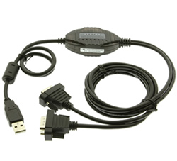 |  | 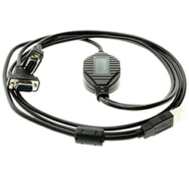 |  | 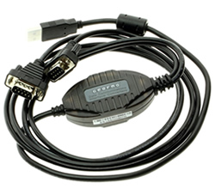

The GM-FTDI2X USB 2.0 to RS232 commercial converter is a universal USB 2-port RS-232 converter that doesn’t need an external power supply. It is compatible with USB and RS-232 standards can convert single-end USB signal to RS-232 signal. It has built-in automatic transmit-receive switch without time delay. The unique I/O circuit can be used to automatically control the direction of data flow making it plug-and-play, it is also applicable to all existing communication software and interface hardware. The GM-FTDI2X supports point-to-point communication with data rate of 300-921600bps. The power indicator and data traffic indicator lights can be used for fault indication.

Features |  |  | Product Information
- Conforms to USB 2.0, USB 1.1, 1.0, EIA RS-232 standards.  - Supports asynchronous point-to-point.  - 2 DB-9 Male connectors with screw lock mechanisms  - Supports automatic data flow control technique.  - Baud rates up to 300-921600bps.  - ±15KV ESD surge protection.  - 3 LED signal lights for PWR, TXD and RXD  - Bus powered  - Supports Win XP/Vista/7/8/10/Mac/Linux.  - 5ft. cable length |  |  | - Model Number: GM-FTDI2X  - Package Contents:  - 5ft. USB to RS-232 Adapter  - Driver Disk  - Optional Accessories: N/A

Specifications
OVERVIEW
Interface | USB to 2 Serial DB-9 male connectors.
Port Connections | (2) Serial DB-9 male | USB-A male to Host.
Available Power Modes | Bus Powered.
Electrical Protection | ±15KV electrostatic protection.
Transmission Media | Twisted-pair cable or shielded cable
PHYSICAL FEATURES
LEDs | (1 per connector) PWR, TXD, RXD
Construction | Plastic
Color | Black
Dimensions | 1500 mm cable length
Weight | 0.318 lbs.
SIGNALS
USB Signals | VCC, DATA+, DATA-, GND, FG
RS-232 Signals | DCD, RXD, TXD, DTR, GND, DSR, RTS, CTS, RI
COMMUNICATION MODES
 | Point-to-point communication
WORKING MODES
 | Asynchronous point to point
TRANSMISSION
Baud Rates | 300 - 9,600 Kbps automatic detection of the transmission rates.
Transmission Distance | 5 meters for RS-232 interface and no more than 5 meters for the USB port.
ENVIRONMENT
Operating Temperature | -40°C to 85°C
Relative Humidity | 5% to 95%
PRODUCT URL
GM-FTDI2X Product Page | http://www.gearmo.com/shop/usb-2-0-to-serial-professional-2port-converter/

